 Requirements for running the application:-

1. The latest version of Google chrome.
2. The latest version of Angular 6.
3. The latest version of the Eclipse IDE for Java EE and web applications.

Steps to run the application:-

1. Download the **pro.rar** file from https://drive.google.com/open?id=1nDXQRXXuBcdohSd__eFa9lT1civFPT42
2. Unzip the **pro.rar** file.
3. Open the command prompt and go to the directory of the unzipped folder.

Change the cmd path to the **proj** folder in the unzipped folder.  
(cd pro, cd pro, cd proj).

1. Type **npm start** or **ng serve** on the command window.
2. Download the folder **extern** from

https://drive.google.com/open?id=1ttFu-WNwRP5rz1fvELv_R03x34lHfxo9

1. Open the Eclipse IDE and go to file->import->existing maven project and select the folder **extern** downloaded in the first step.
2. Run the application. (Please make sure that the tomcat server is set up on port 8080 which is the default port if it not used by another application. The angular project is coded to access that port for backend services.)
3. (chrome.exe --user-data-dir="C:/Chrome dev session" --disable-web-security)

Paste this command on the run window. This will open a new **chrome** browser which allow access to no **'access-control-allow-origin'** header request.

1. Go to <http://localhost:4200/> in this browser.
2. The login form should be displayed

4 Users have already been added.

Username name password

101 John password1

102 David password2

103 Richard password3

104 Amit password4

You can register more users by clicking on the ‘create an account’ link on the login page. The username is generated by the backend and will be displayed after you enter your name and password.

The homepage displays the available events which is returned from the backend. The ‘see location’ button will display a google map view of that location in place of the thumbnail and the ‘visited’ button will add the event to the history of that particular user which can be checked by clicking on the see history button on the top right.

An internet connection is required for the ‘sopra steria’ logo to load on the top and for the locations to be loaded on google maps. However, the images of the events are locally stored, hence do not require an internet connection.

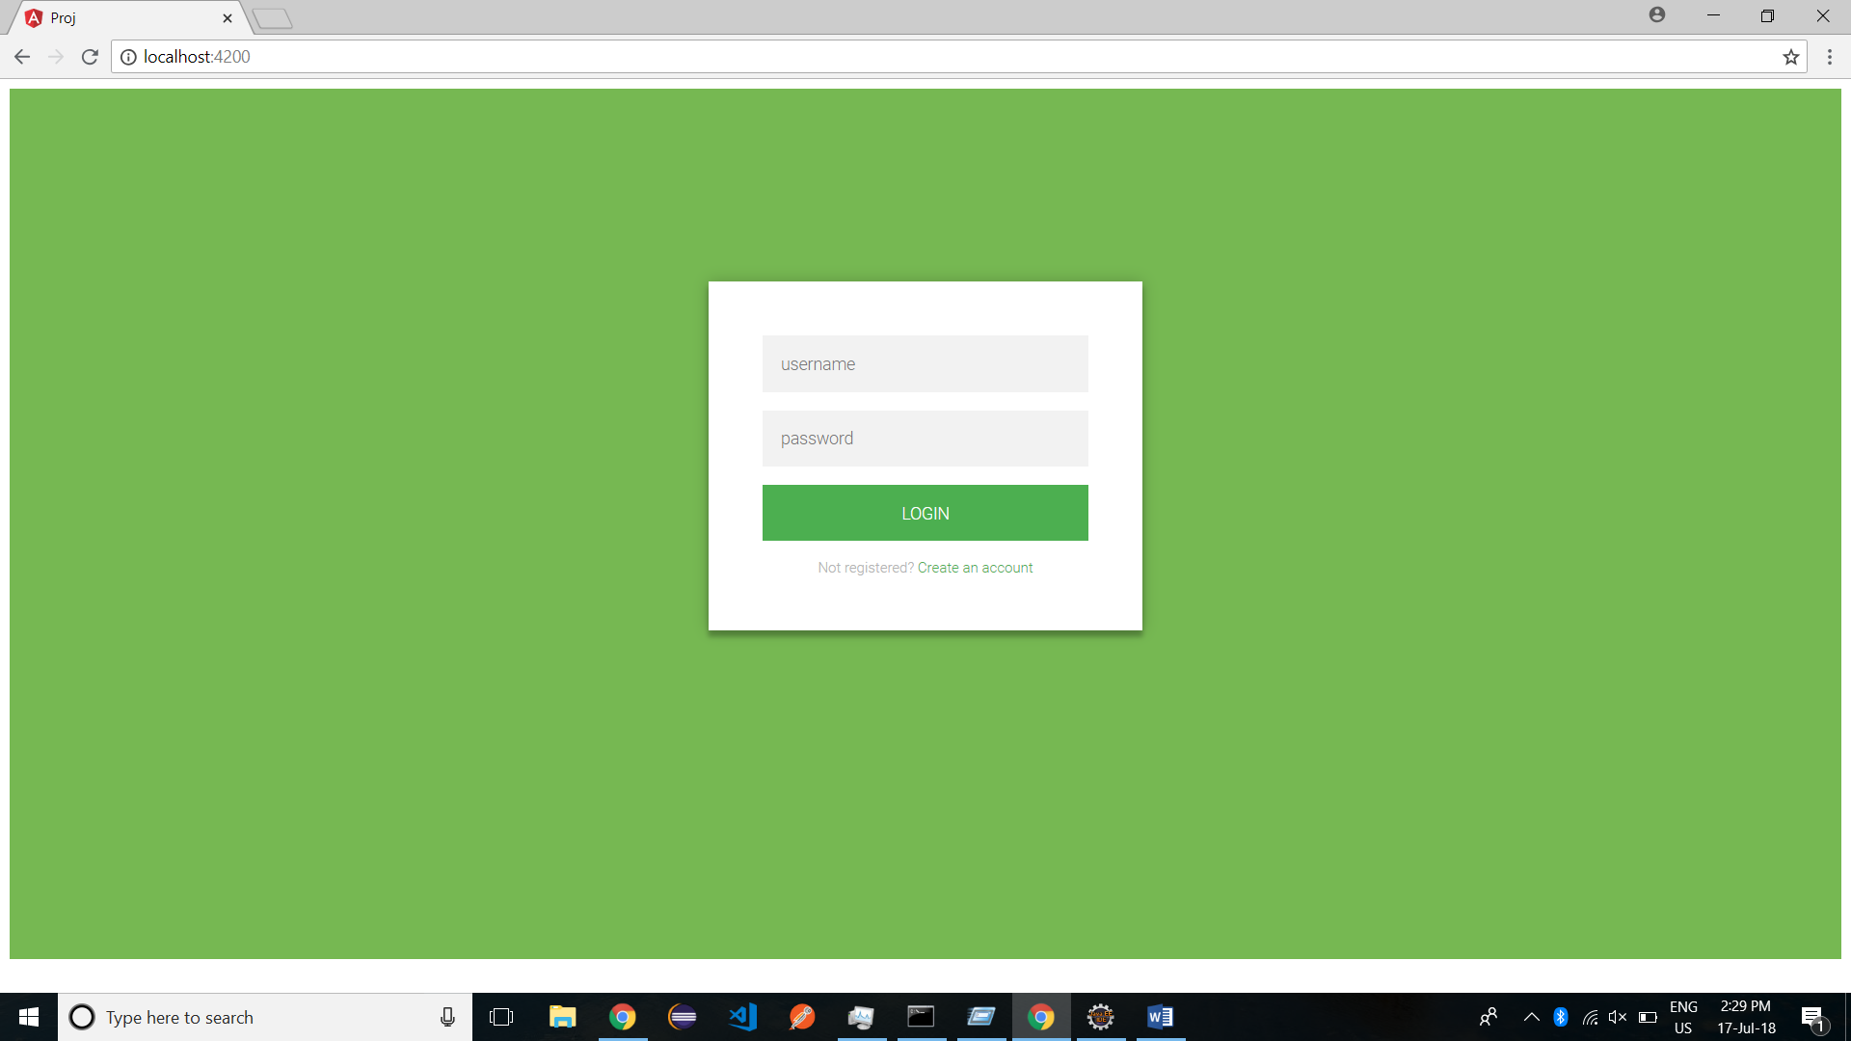

Login and registration forms

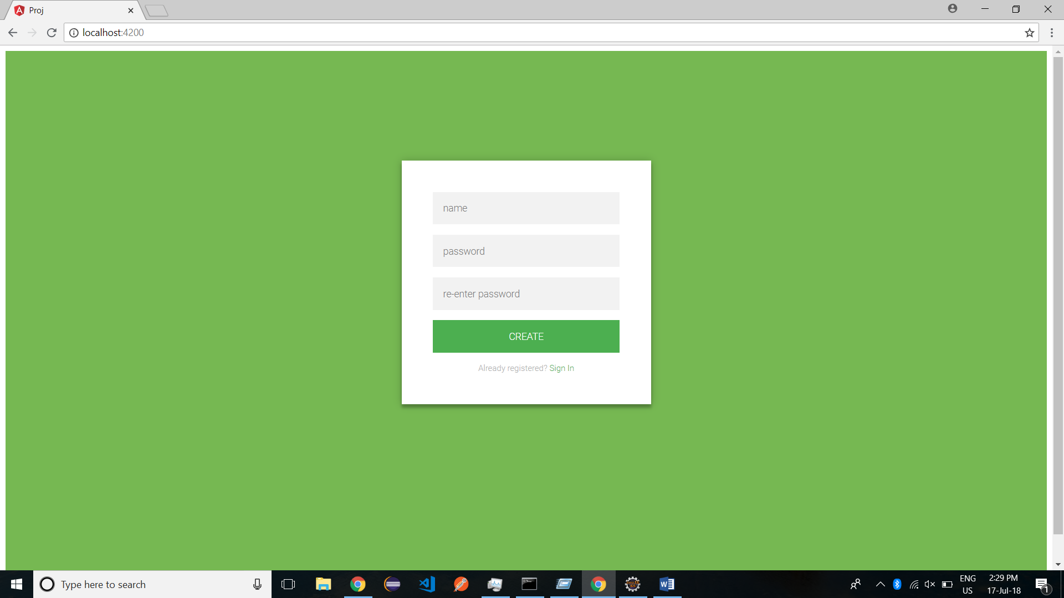

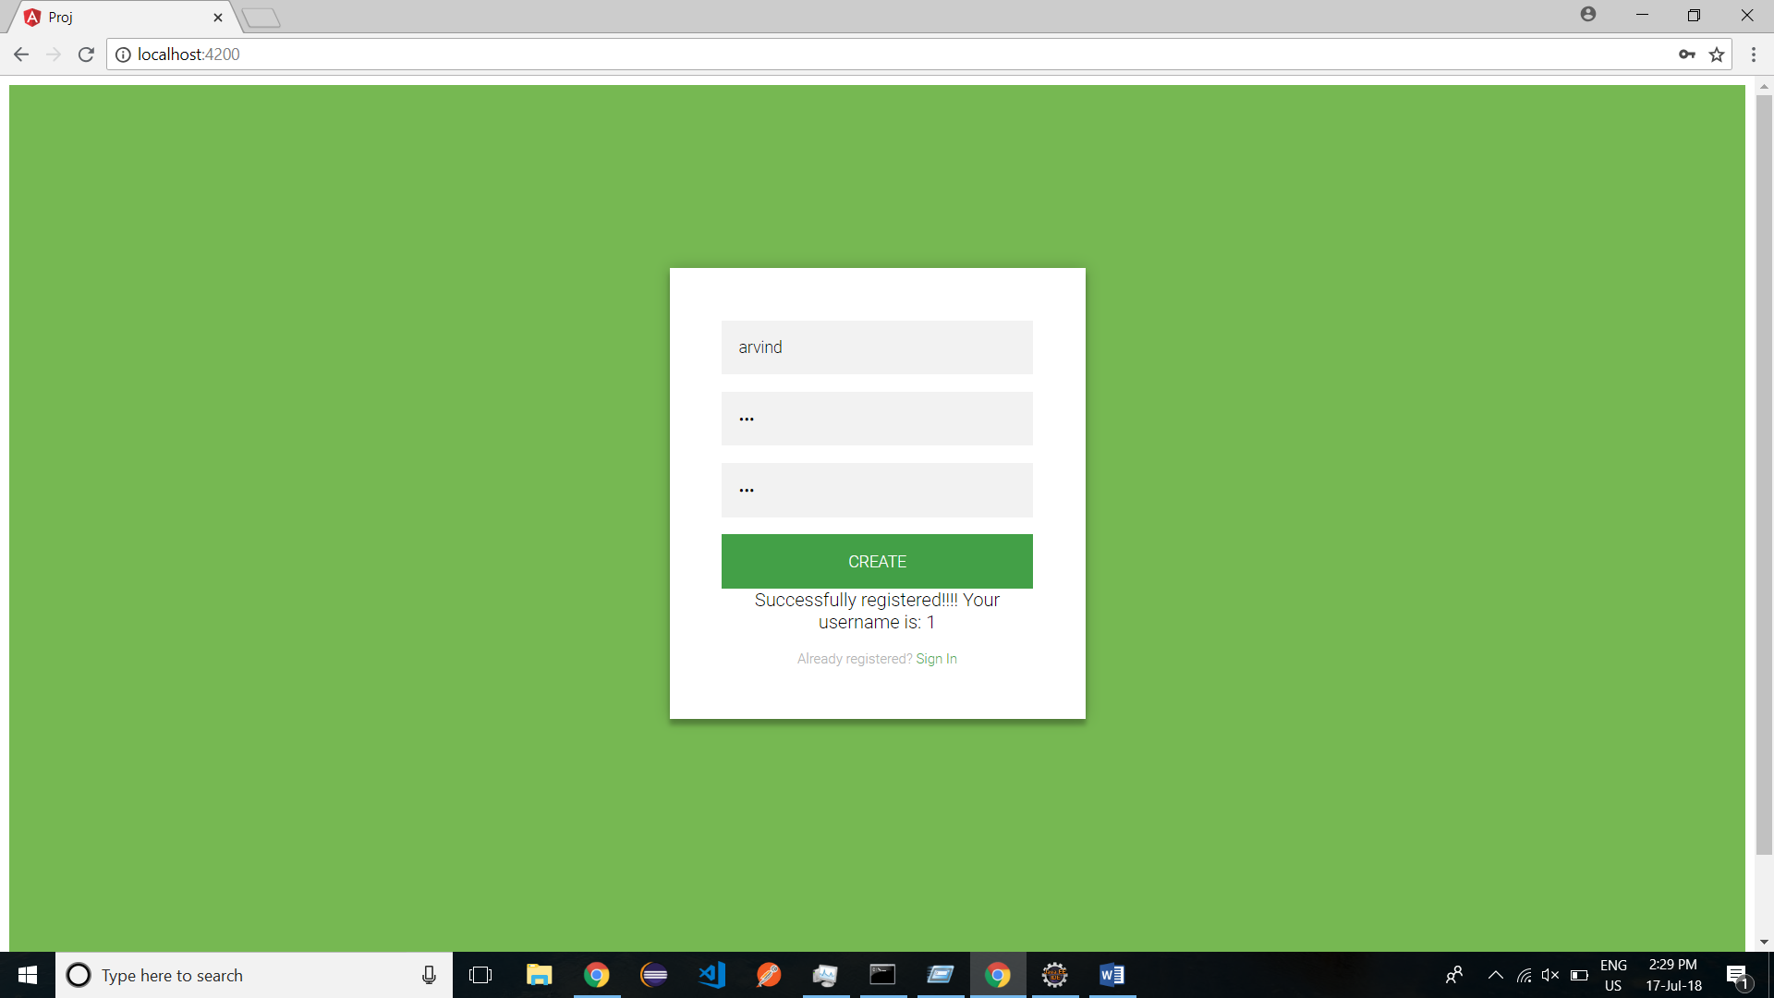

Main page after logging in

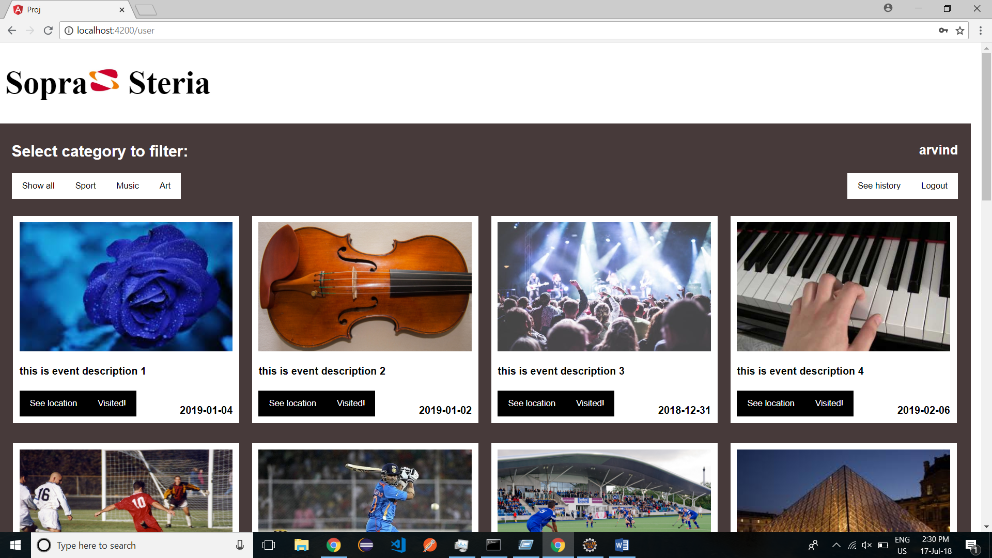

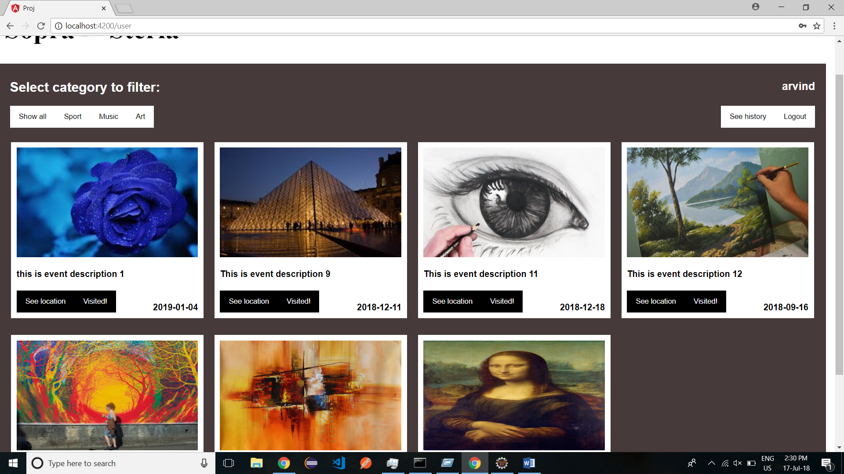

Category filter selected as “art”

“See location” button clicked on event 6

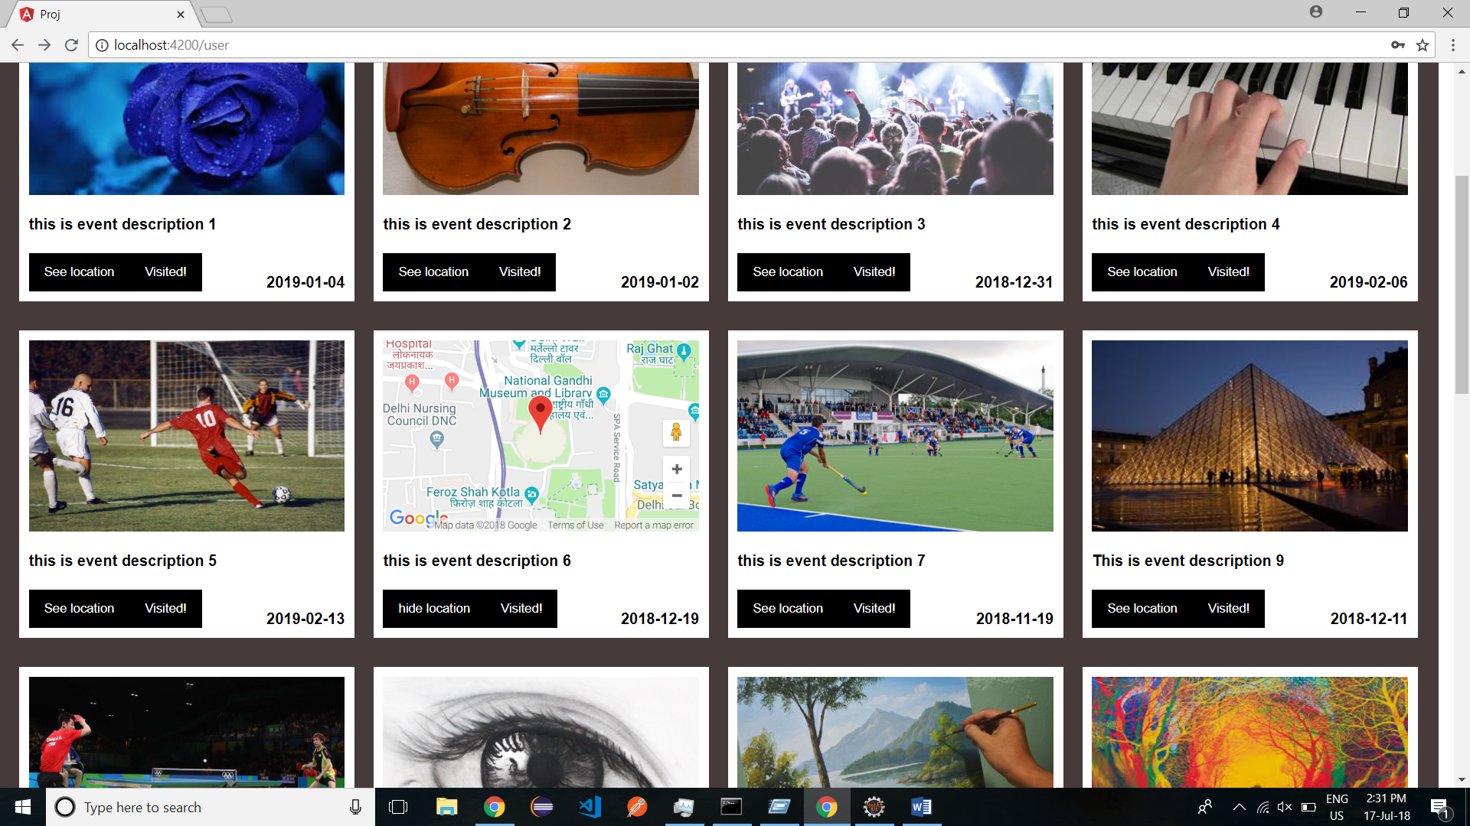

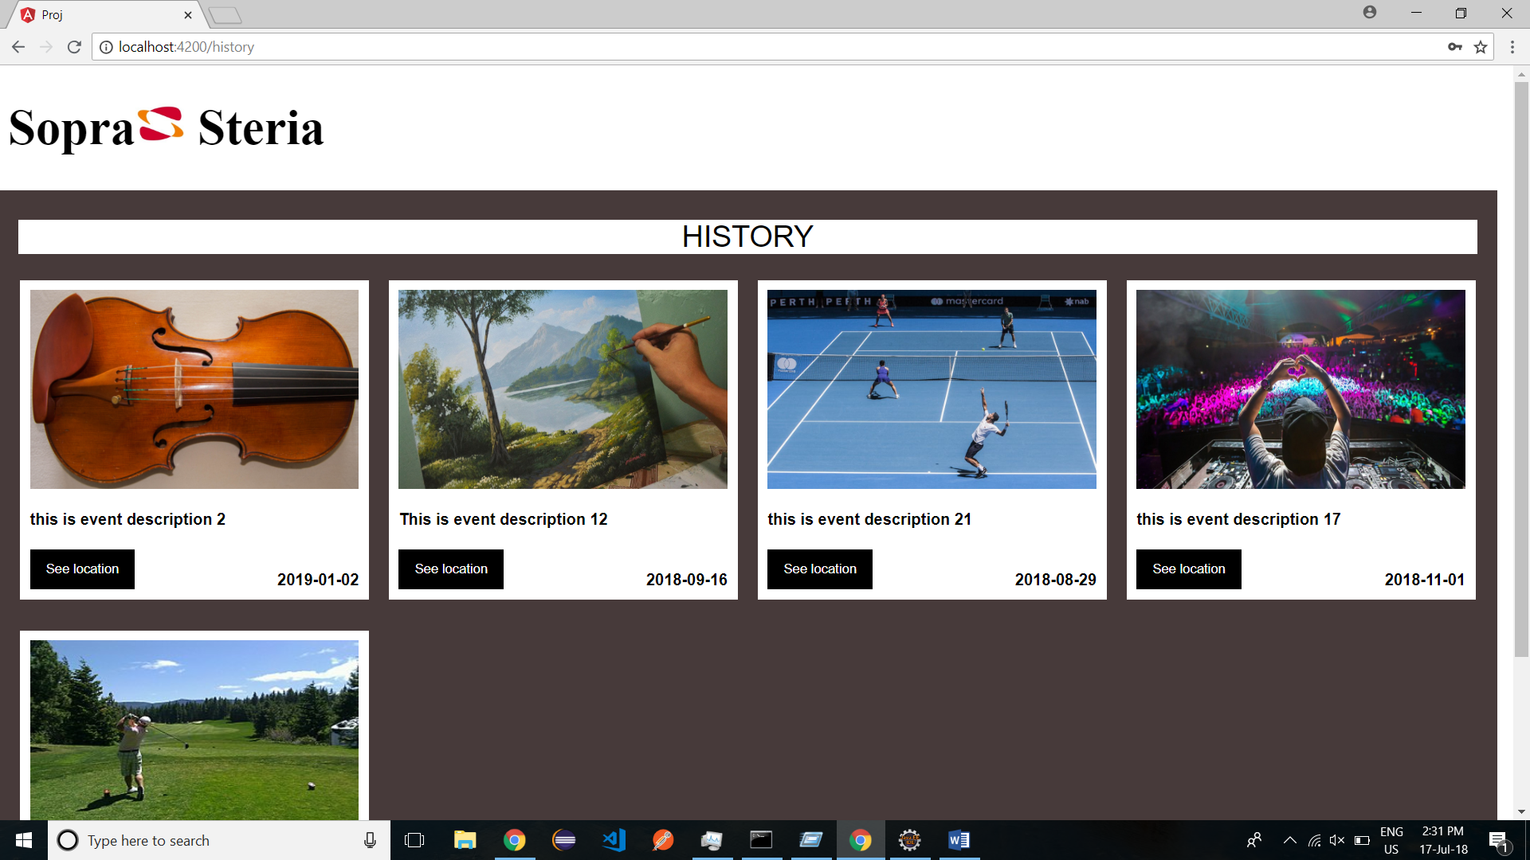

Event history for the user logged in

“see location “ button clicked on the history page

